**CSC 4111: Software Engineering Lab**

**Assignment 2: Software Requirement Specification**

**Submission type: Group**

**Points: 75**

**Submission Deadline: TBD**

## Project Proposal

The goal of this assignment is to develop a detailed software requirement specification for your term project. In the Lecture 3, we talked about several techniques to collect requirements. Among those, for the term project, you will be using group brainstorming strategy. **Please read the following steps to follow an organized procedure to determine requirements.**

## Steps: Part 1

1. Schedule one or more meetings with your teammates outside the class. All the team members must attend these meetings.
2. First, identify the different stakeholders of your software and list them.
3. For each type of stakeholder, identify the set of features that he/she needs from the system. Create a list of all the features for all the stakeholders.
4. There are six types of non-functional requirements as discussed in the class. For each category, identify the non-functional requirements for your project. For example, what would be the security requirements of your software? What are the performance requirements? What are the privacy requirements? And so on.
5. Once the team have prepared a list of functional and non-functional requirements the entire team should go over the list. Have you covered all the requirements? Is there anything else that you need to add? Brainstorm!
6. Once you’re satisfied with the prepared list, you need to start populating the SRS form for each requirement. Take the requirements one by one. Discuss with your teammates on how this feature should work**. Provide as much description as possible**. Do not forget about the alternate scenarios or failure cases. Once the team members are satisfied that there is no ambiguity in their understandings and the description is sufficient to develop that feature, you may move on to the next requirement.
7. Once you have completed the SRS forms for all the listed requirements, the team members need to do a requirement validation. We would recommend completing the SRS forms in the first meeting and schedule a follow-up meeting for validation. Often, we get bored when we are doing the same task for long time. Since requirement validation is very important, you need to be alert. That’s why a separate meeting will be more productive.
8. In the Class, we discussed 10 characteristics of a good requirement (also repeated in the lab). Review each SRS form to ensure that all the requirements maintain those 10 characteristics.
9. Fill out the Assignment 2 template. Make sure that it includes completed SRS form for each identified requirement.
10. Once you’re satisfied the team lead should submit the completed SRS forms in a single doc file in Canvas.

## Steps: Part 2

1. In this step, you will be adding the SRS forms in Github. We will be using the “Issues” tab on Github. In the assignment-1 of CSC4110, you have created a repository under the **WSU-4110** organization for the term project.
2. Discuss among the team members and assign the responsibility of adding the issues to one of the members. He should go to the Issues tab of the project repository. 
3. For each of the SRS, add a new issue in the repository. I have attached a markdown template (github-markdown-srs.txt) which will show an SRS as following: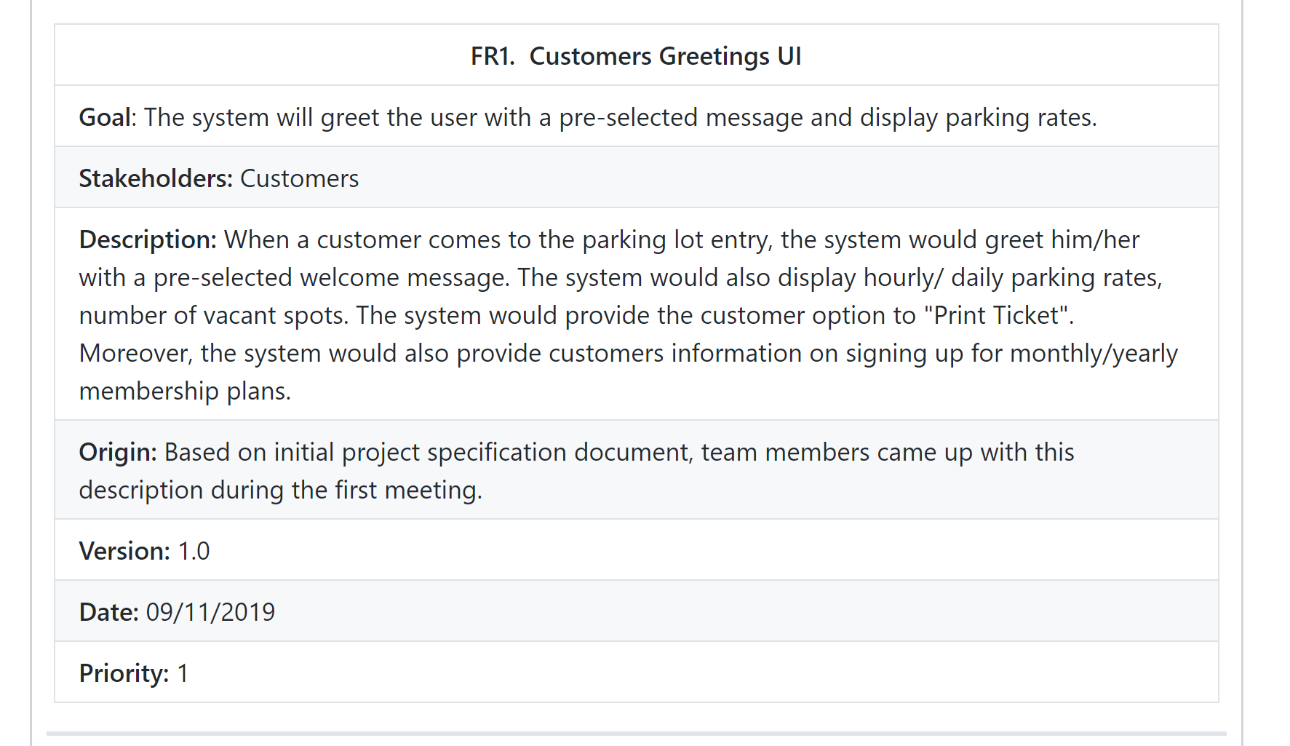
4. Go to “Labels settings” -> Edit label

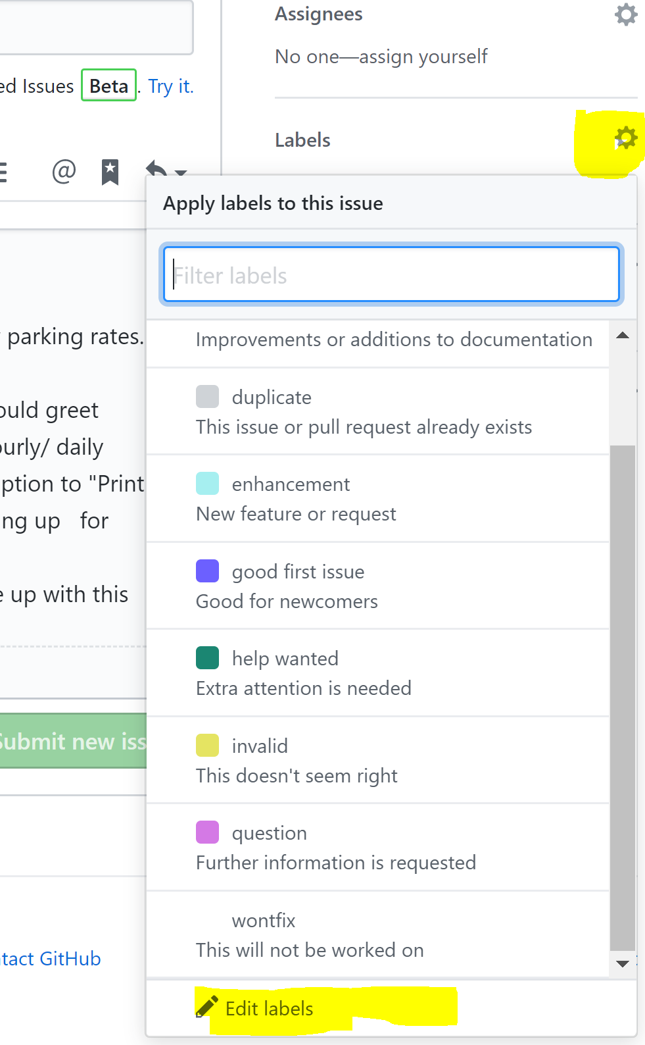

1. **Add three new labels** named “Features”, “Functional”, and “Non-Functional”. You may use any color that you like for the labels. Assign appropriate labels to each of the created issues. For example, a Functional requirement would be assigned both “Functional” and “Feature”.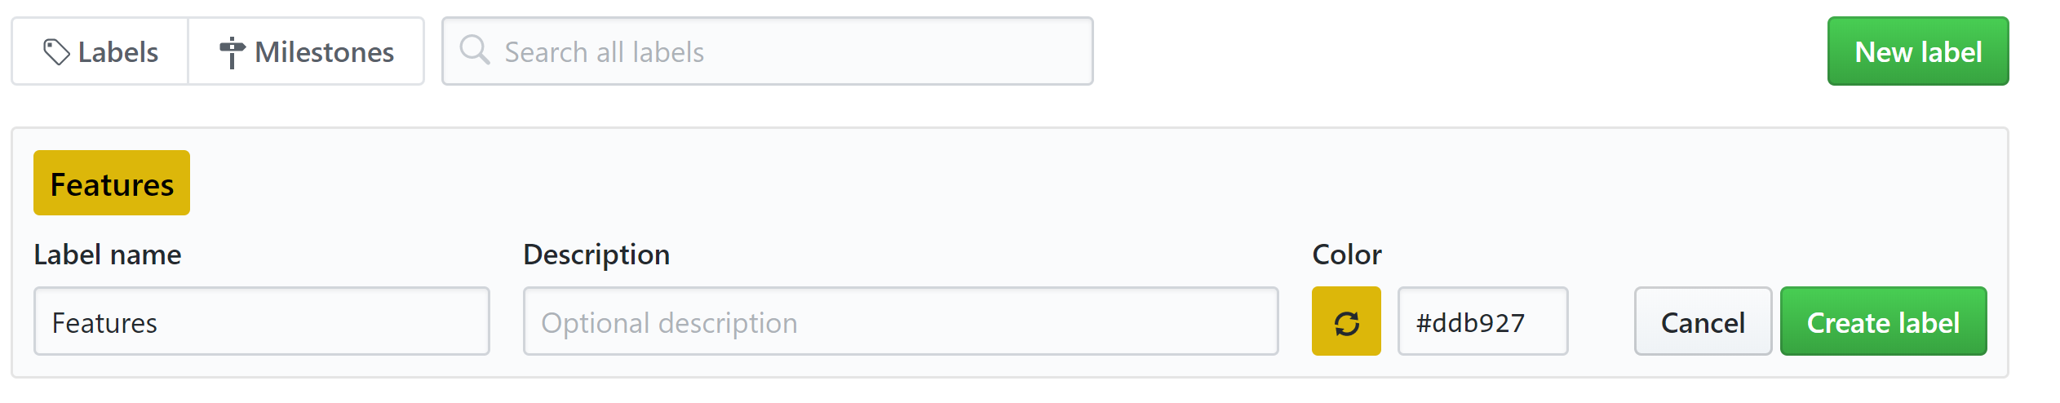
2. Use the “Milestones” tab to create three milestones named “Sprint-1”, “Sprint-2” and “Sprint-3”. You will assign the milestones tag after the sprint planning.

## Requirements

1. Each project must include **at least 15 functional and 5 non-functional requirements**. If you cannot think of enough functional requirements, then you need to breakdown a larger requirement into multiple smaller requirements. Large requirements are difficult to plan as well as difficult to estimate. It’s better to create fine-grained requirements.
2. Although, this assignment requires a group submission, we require each member to spend his/her fair share of efforts working on this assignment. Specially, all the members are expected to attend the group meetings and contribute.
3. *This assignment will be graded based on following four criteria:*
   1. *Does the submission include adequate functional and non-functional requirements?*
   2. *Does each of the SRS include all the attributes suggested in the supplied template?*
   3. *Does each of the SRS description maintain the ten characteristics of good requirements?*
   4. *Were all the SRS added to the project Github repository before the submission deadline?*

## Submission

* Part1: On canvas. Acceptable formats include doc, docx or odt. File name as well as the header must include your team name. For example, a good file name for this assignment is: *Assignment_2_teamname.docx*
* Part2: Complete part 2 on Github